Screenshots of Story
Date | 04 February 2026
Team ID | LTVIP2026TMIDS24102
Project Name | Heritage Treasures: An In-Depth Analysis of UNESCO World Heritage Sites
Maximum Marks | 2 Marks

Story:
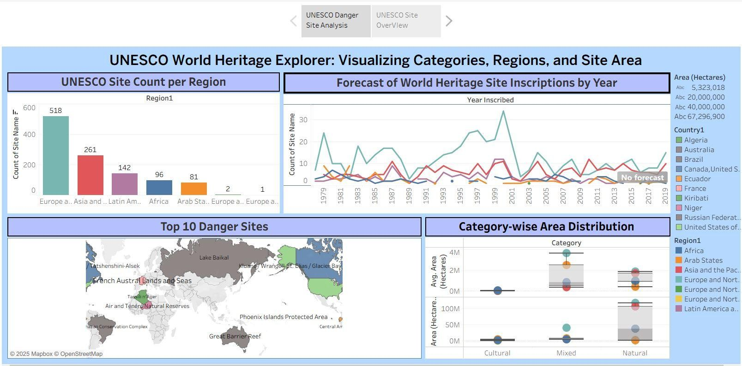

Story-1:
https://public.tableau.com/views/Story1_17427207515630/Story1?:language=en-US&publish=yes&:sid=&:redirect=auth&:display_count=n&:origin=viz_share_link

Story-2:
https://public.tableau.com/views/Story2_17427208595170/Story2?:language=en-US&publish=yes&:sid=&:redirect=auth&:display_count=n&:origin=viz_share_link
